|  |  |
| --- | --- |
| **EX.NO:** | **PROGRAMS ON SELECTION AND ITERATION OPERATIONS** |
| **DATE:** |

**AIM :**

Write a python program get an integer from a user. If the number is odd, then find the factorial of the number and find the number of digits in the factorial of the number. If the number is even then check the given number is a palindrome or not **ALGORITHM :**

**STEP 01:** Read the input number

**STEP 02:** Find the given number is even or not

**STEP 03**: If the number modulo2 equals 0, the number is even

**STEP 04:** If the number is even. reverse the number, If the reversable number is equal to the given input number it is palindrome and print the given number is palindrome otherwise print it is not a palindrome.

**STEP 05:** If the number is odd, find the factorial of the given number, print the

Factorial of the given number.

**STEP 06:** After finding the factorial of the number count the number of digit in

the factorial number.

**STEP 07:** Run the program and get the input.

**PROGRAM :**

n=int(input("enter a number")) fact=1 count=0 temp=n

rev=0 if(n%2!=0):

for i in range(1,n+1):

fact=fact*i

print("the factorial number =",fact) while(fact!=0): fact=fact//10 count=count+1

print("the total number of digits =",count)

elif(n%2==0):

while(n>0): digits=n%10 rev=rev*10+digits n=n//10

if(rev==temp):

print("Palindrome")

else: print("not a palindrome")

else:

print("Invalid entry")

**OUTPUT**

**IF THE NUMBER IS EVEN,** 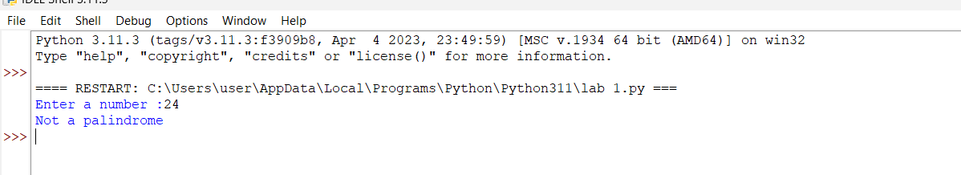

**IF THE NUMBER IS ODD,** 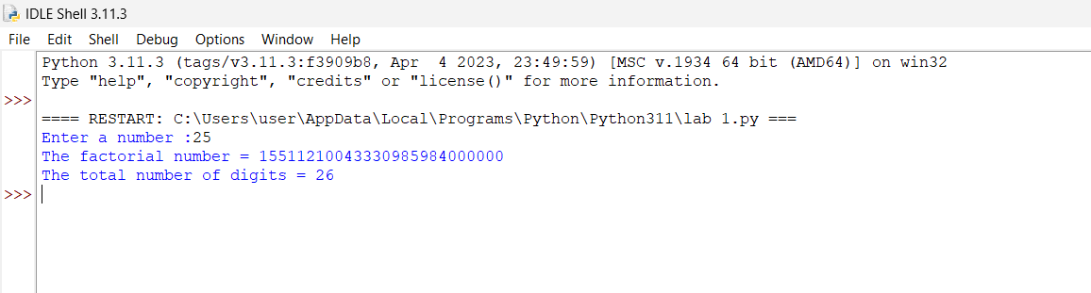

|  |  |  |
| --- | --- | --- |
| **DEPAR** | **RTMENT OF EEE** | |
| Preparation (Algorithm) | 4 |  |
| Observation (Program) | 4 |  |
| Results (Output) | 4 |  |
| Interpretation (Validation) | 4 |  |
| Viva - Voce | 4 |  |
| Total | 20 |  |

**RESULT :**

Thus python program get an integer from a user. If the number is odd, then find the factorial of the number and find the number of digits in the factorial of the number. If the number is even then check the given number is a palindrome or not has been executed successful and verified.